In jsfiddle I have created an account and implemented code on get directions page. I have done code in HTML, JavaScript and CSS. This is how it looked after running the code in jsfidde.

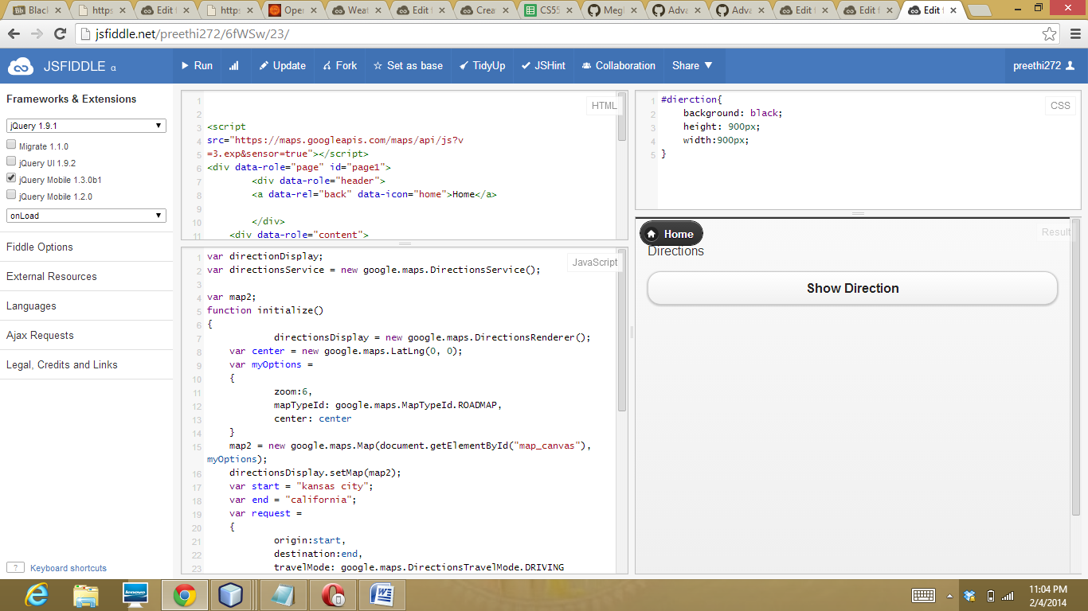

After clicking on get directions button the desired route is displayed this was done using the google maps service.

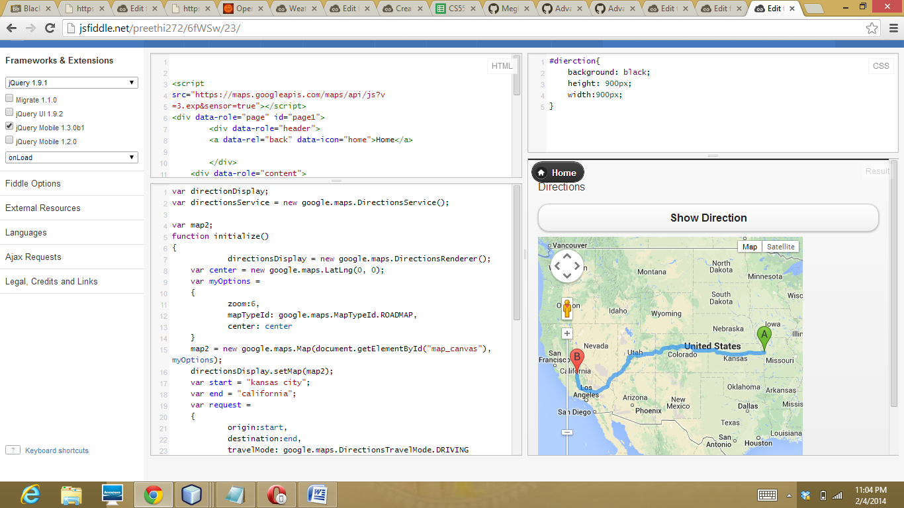

Now using the Opera Mobile emulator I have uploaded my directions page.

